DATE: April 27, 2022

TO: Dr. Emin Kececi

FROM: UltraVisor-C Team

SUBJECT: Key Features of the Final UltraVisor-C Prototype

The current pandemic poses a serious threat to people in high-risk environments, especially hospital workers. Our team designed the UltraVisor-C, a device that improves upon the UVisor, an existing face shield that utilizes UV-C technology to sanitize the air. UV-C light has a proven efficacy of 99% against Covid-19. However, a key flaw of the UVisor is its inability to sanitize outgoing air, which poses a major safety concern, since users can infect patients and other staff. The UltraVisor-C builds upon the original UVisor by sanitizing both incoming and outgoing air, in addition to improving the weight, battery life, comfort, audibility, and ease of use.

The UltraVisor-C is a face shield. Figure 1 shows the final prototype of our device. The overall product has dimensions of 200mm x 170mm x 290mm, and weight of 916g. The battery holder is situated on top of the sanitation chamber, which is situated on top of the head. The chamber is divided into 2 compartments (one for inhaled air and the other for exhaled), both containing LED strips that act as a substitute for UV-C. Two fans turning in opposite directions direct air between the chamber and the visor. A detachable vinyl visor allows for full face visibility, and the elastic fabric and foam lining prevent air leakage. An adjustable hat helps fix the device on the head. It is detachable and can be replaced to fit the user’s preference.

The prototype used 3D-printed materials for the main structure with Open Source SLDPRT files. These printed parts are attached using epoxy, hot glue, and superglue. For the removable cloth parts, consisting of the hat and the sealing cloth, velcro strips help to attach them to the chamber and visor. Finally, the visor is removable, in case the user needs to eat, drink, or touch their face.

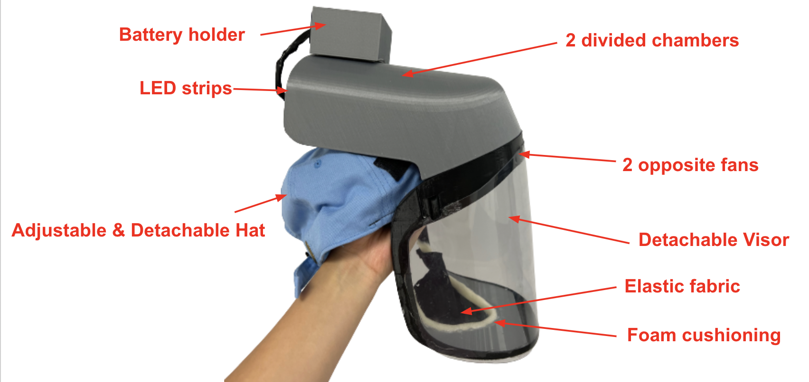

Figure 1: Final prototype & Components of Ultravisor-C

The components are assembled such that most of the air is sealed inside the product with the built-in airflow mechanism. As shown in Figure 2, the green arrows represent the direction of the air flowing inside the UVisor. The air is pulled in through the inhale chamber with a fan blowing the air into the visor. After a complete circulation of air within the device, the exhaled air will be directed outwards into the exhale UV-C chamber with the other reversed fan.

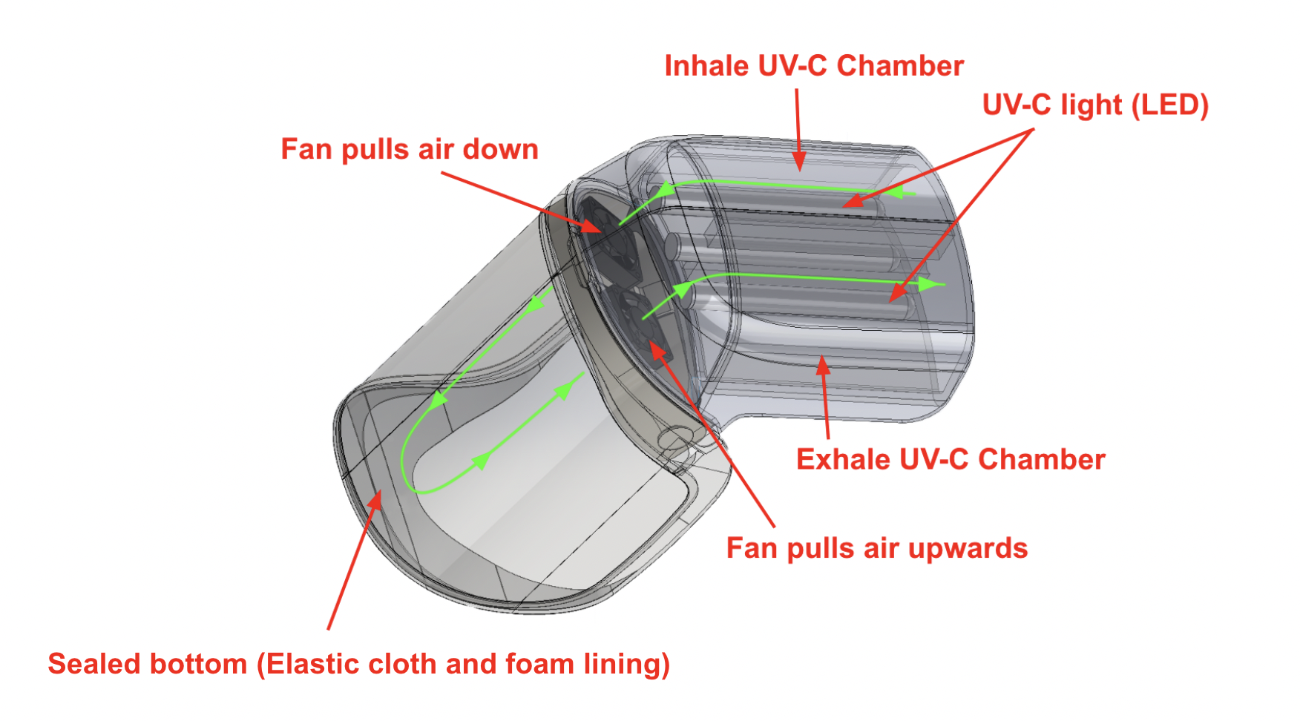

Figure 2: The airflow mechanism (Circulation of air) of UltraVisor-C

In our Airflow test, we measured the quantity of air entering and exiting the device with an airflow probe. Since we know that UV-C light can achieve an efficacy rate of 99% purification for air entering the UVisor, and we are reusing the same UV-C technology to purify the exhaled air, we know the device achieves 99% purification of exhaled air if airflow entering and exiting the UVisor are equal. First, we placed the airflow probe over opening of the inhale chamber until the reading was steady. We then repeated the process with the probe over the exhale chamber. We conducted 3 trials of this test. The target values for the volume of air entering the device is 10 L/min, the highest volume that an average adult breathes in and out in 1 minute. Since the airflow probe measured in ft3/min, we manually converted the values to L/min to compare with the target value of ≥ 10 L/min. As shown in Table 1, the volume of air entering the device in every trial was ≥ 10 L/min and approximately equal to the volume of air exiting the device, so the device passed the test, and we concluded that the air supply is sufficient and completely sanitized.

**Table 1: Flow rate and volume of air in 1 minute**

| Trial | Flow rate: Air In (cfm) | Volume: Air In (L/min) | Flow rate: Air Out (cfm) | Volume: Air Out (L/min) |
| --- | --- | --- | --- | --- |
| 1 | 4.6 | 130.257 | 5.2 | 147.247 |
| 2 | 5.2 | 147.247 | 5.2 | 147.247 |
| 3 | 4.7 | 133.089 | 4.8 | 135.920 |

We conducted audibility testing to measure how much the device affects audibility. For our testing procedure, we first recorded ourselves saying “UltraVisor-C” using voice memos. We played the recording and measured the decibel level it reached using an online decibel meter. Then, we measured the decibel level while a team member wore the device and played the voice memo from inside the visor. Since N95 masks have been proven to reduce speech audibility by about 2.7 decibels, the target value of reduction for each recording is ≤ 2.7 decibels. We conducted 3 trials of this process, and the data is shown below in Table 2. We calculated the average of all 3 trials and then calculated the difference. There was only a 1.867 dB reduction between wearing the device versus speaking normally, so our prototype passed this test.

**Table 2: Decibel measurements of regular speech vs. wearing the device**

|  | **Standard (dB)** | **UltraVisor-C (dB)** |
| --- | --- | --- |
| **Round 1** | 87.1 | 85 |
| **Round 2** | 87.4 | 84.8 |
| **Round 3** | 86.8 | 85.9 |
| **Average** | 87.1 | 85.23 |

In our Safety test, we first rubbed a balloon across the device surface to ensure that there were no sharp corners, and it did not pop. Secondly, we observed whether electrical wires are exposed on the exterior, and they are not. Thirdly, we ensured that the battery is fully covered and not potentially exposed to sunlight. We repeated the test twice to account for regions that may have been missed by the balloon or battery areas and wires that may have been missed. The device passed all rounds of testing, so we conclude that our device is safe to use.

In our Battery Life test, we calculated the battery life from our data, given in terms of voltage, milliamp hours. Since it is a straightforward calculation, we performed this test only once. The target battery life is ≥ 8 hours because we assume hospital staff will have a break every 8 hours. The calculated battery life of our device was 32.5 hours, so our device passed the test, and we can conclude that the battery does not need to be recharged during a single shift.

In our Comfortability test, we asked 22 people of varying head sizes to wear the device and rate their opinions on a user defined scale, and we then calculated the average of all the ratings according to our UDS (Table 3). The target value was an average rating of ≥ 4, which specified that the device is easier to breathe in than an N95 mask and components do not get in the way of work. Our final average rating was 3.7, so the device failed the test, and we cannot conclude that the device is comfortable to wear.

**Table 3: User Defined Scale for Comfort**

| **Value** | **Comfortability** |
| --- | --- |
| 1 | Tubes/battery/other components are extremely inconvenient, prevent movement, and work. Difficult to breathe in. |
| 2 | Tubes/battery/other components are inconvenient and slow down work. More difficult to breathe in than an N95 mask, but still manageable. |
| 3 | Tubes/battery/other components occasionally get in the way of work but it is still manageable to work in. Feels like breathing through an N95 mask. |
| 4 | Tubes/battery/other components don’t get in the way of work but there is a minor impact on performance after prolonged use. Easier to breathe through than an N95 mask, but still feel constrained. |
| 5 | Tubes/battery/other components never get in the way of work and can be worn longer than 4 hours without negative impact on performance. No difficulty breathing. |

Although we planned to conduct a Durability test, we have not performed it yet because we need a fully functioning device to present to our client. We planned on conducting a 6 ft drop test on the device to model what might happen if the user were to drop the device from their head. The test will be repeated 3 times because we assume the device would be dropped at most 3 times in the duration of its usage.

The strengths of our current prototype are that we were able to successfully separate the sanitation of inhaled and exhaled air by dividing the UV-C chamber. In addition to the UV-C lamps on the sides, the added UV-C lamp in the middle provides sufficient sanitation for the air passing through. Furthermore, we created a system using fans to direct the air from the inhale chamber to the exhale chamber. Our airflow testing data shows that the rate of air flowing into the inhale chamber is approximately equal to the rate of air flowing out of the exhale chamber. However, our device has a few limitations. Even though our prototype passed the audibility test we created, the decibel measurements do not account for how muffled speech is. We noticed that when teammates wear the device, their speech is significantly muffled. Secondly, our device has some issues involving adjustability. We used elastic fabric to fit the neck area, but the visor frame around the forehead is not as adjustable. In consequence, individuals with larger or smaller neck sizes may find the device uncomfortable. Lastly, we noticed issues with the battery of the prototype. Although our device is projected to last up to 32.5 hours, we discovered that the voltage drops after long periods of time, so the fan does not consistently move at its maximum speed.

Video link: <https://youtu.be/ixSwmfPEwCU>

Appendix A. Table Showing Test Results

| **Criteria** | **Test** | **Evaluation** |
| --- | --- | --- |
| **Safety** | Balloon test | Pass |
| Exposed wires count | Pass |
| **Battery life** | ≥ 4 hours | Pass |
| **Sanitation of exhaled air** | Volume ≥ 6 L/min | Pass |
| **Audibility** | ≤ 2.7 dB difference | Pass |
| **Weight** | ≤ 2.5 lbs | Pass |
| **Comfort** | ≥ 4 on UDS | Fail |
| **Maintainability** | Clean time ≤ 30 min | Pass |
| **Durability** | 6 ft. drop test | TBD |